Geophysical Research Letters
Supporting Information for

Magnitudes and spatial patterns of interdecadal temperature variability in CMIP6

L. A. Parsons¹, M. K. Brennan¹, R. C. J. Wills¹, C. Proistosescu^{1,2,3,4}
¹ Department of Atmospheric Sciences, University of Washington, Seattle, WA
² Joint Institute for the Study of the Atmosphere and Ocean, University of Washington, WA
³ Department of Atmospheric Sciences, University of Illinois Urbana-Champaign, IL
⁴ Department of Geology, University of Illinois Urbana-Champaign, IL

Contents of this file

Figures S1 to S8
Table S1
Introduction
Figure S1 shows trends in global-mean surface air temperature (GMST) in instrumental-based data and in 39 Coupled Model Intercomparison Project, Phase 6 (CMIP6) pre-industrial Control (piControl) simulations, Figure S2 shows spectral coherence of local temperature and GMST at interdecadal timescales in the last 400 years of 39 CMIP6 piControl simulations, Figure S3 shows spectral coherence of local temperature and GMST at interdecadal timescales in the last 400 years of 30 CMIP5 piControl simulations, Figure S4 shows spectral coherence of local temperature and GMST at interdecadal timescales in the last 330 years of 15 CMIP3 piControl simulations, Figure S5 shows spectral coherence of local temperature and GMST at interdecadal timescales 1915-2014 CE in 37 CMIP6 historical simulations, Figure S6 shows the century to century variability in interdecadal GMST standard deviation and the full GMST time series from 39 CMIP6 piControl simulations, Figure S7 shows the difference in spectral coherence in transiently forced and piControl CMIP5 and CMIP6 simulations, Figure S8 shows the standard deviation of local interdecadal temperature variability in CMIP5 and CMIP6 piControl simulations and change in interdecadal variability in the historical simulations relative to the piControl simulations. Table S1 lists the CMIP3, CMIP5, and CMIP6 models analyzed in figures and text.
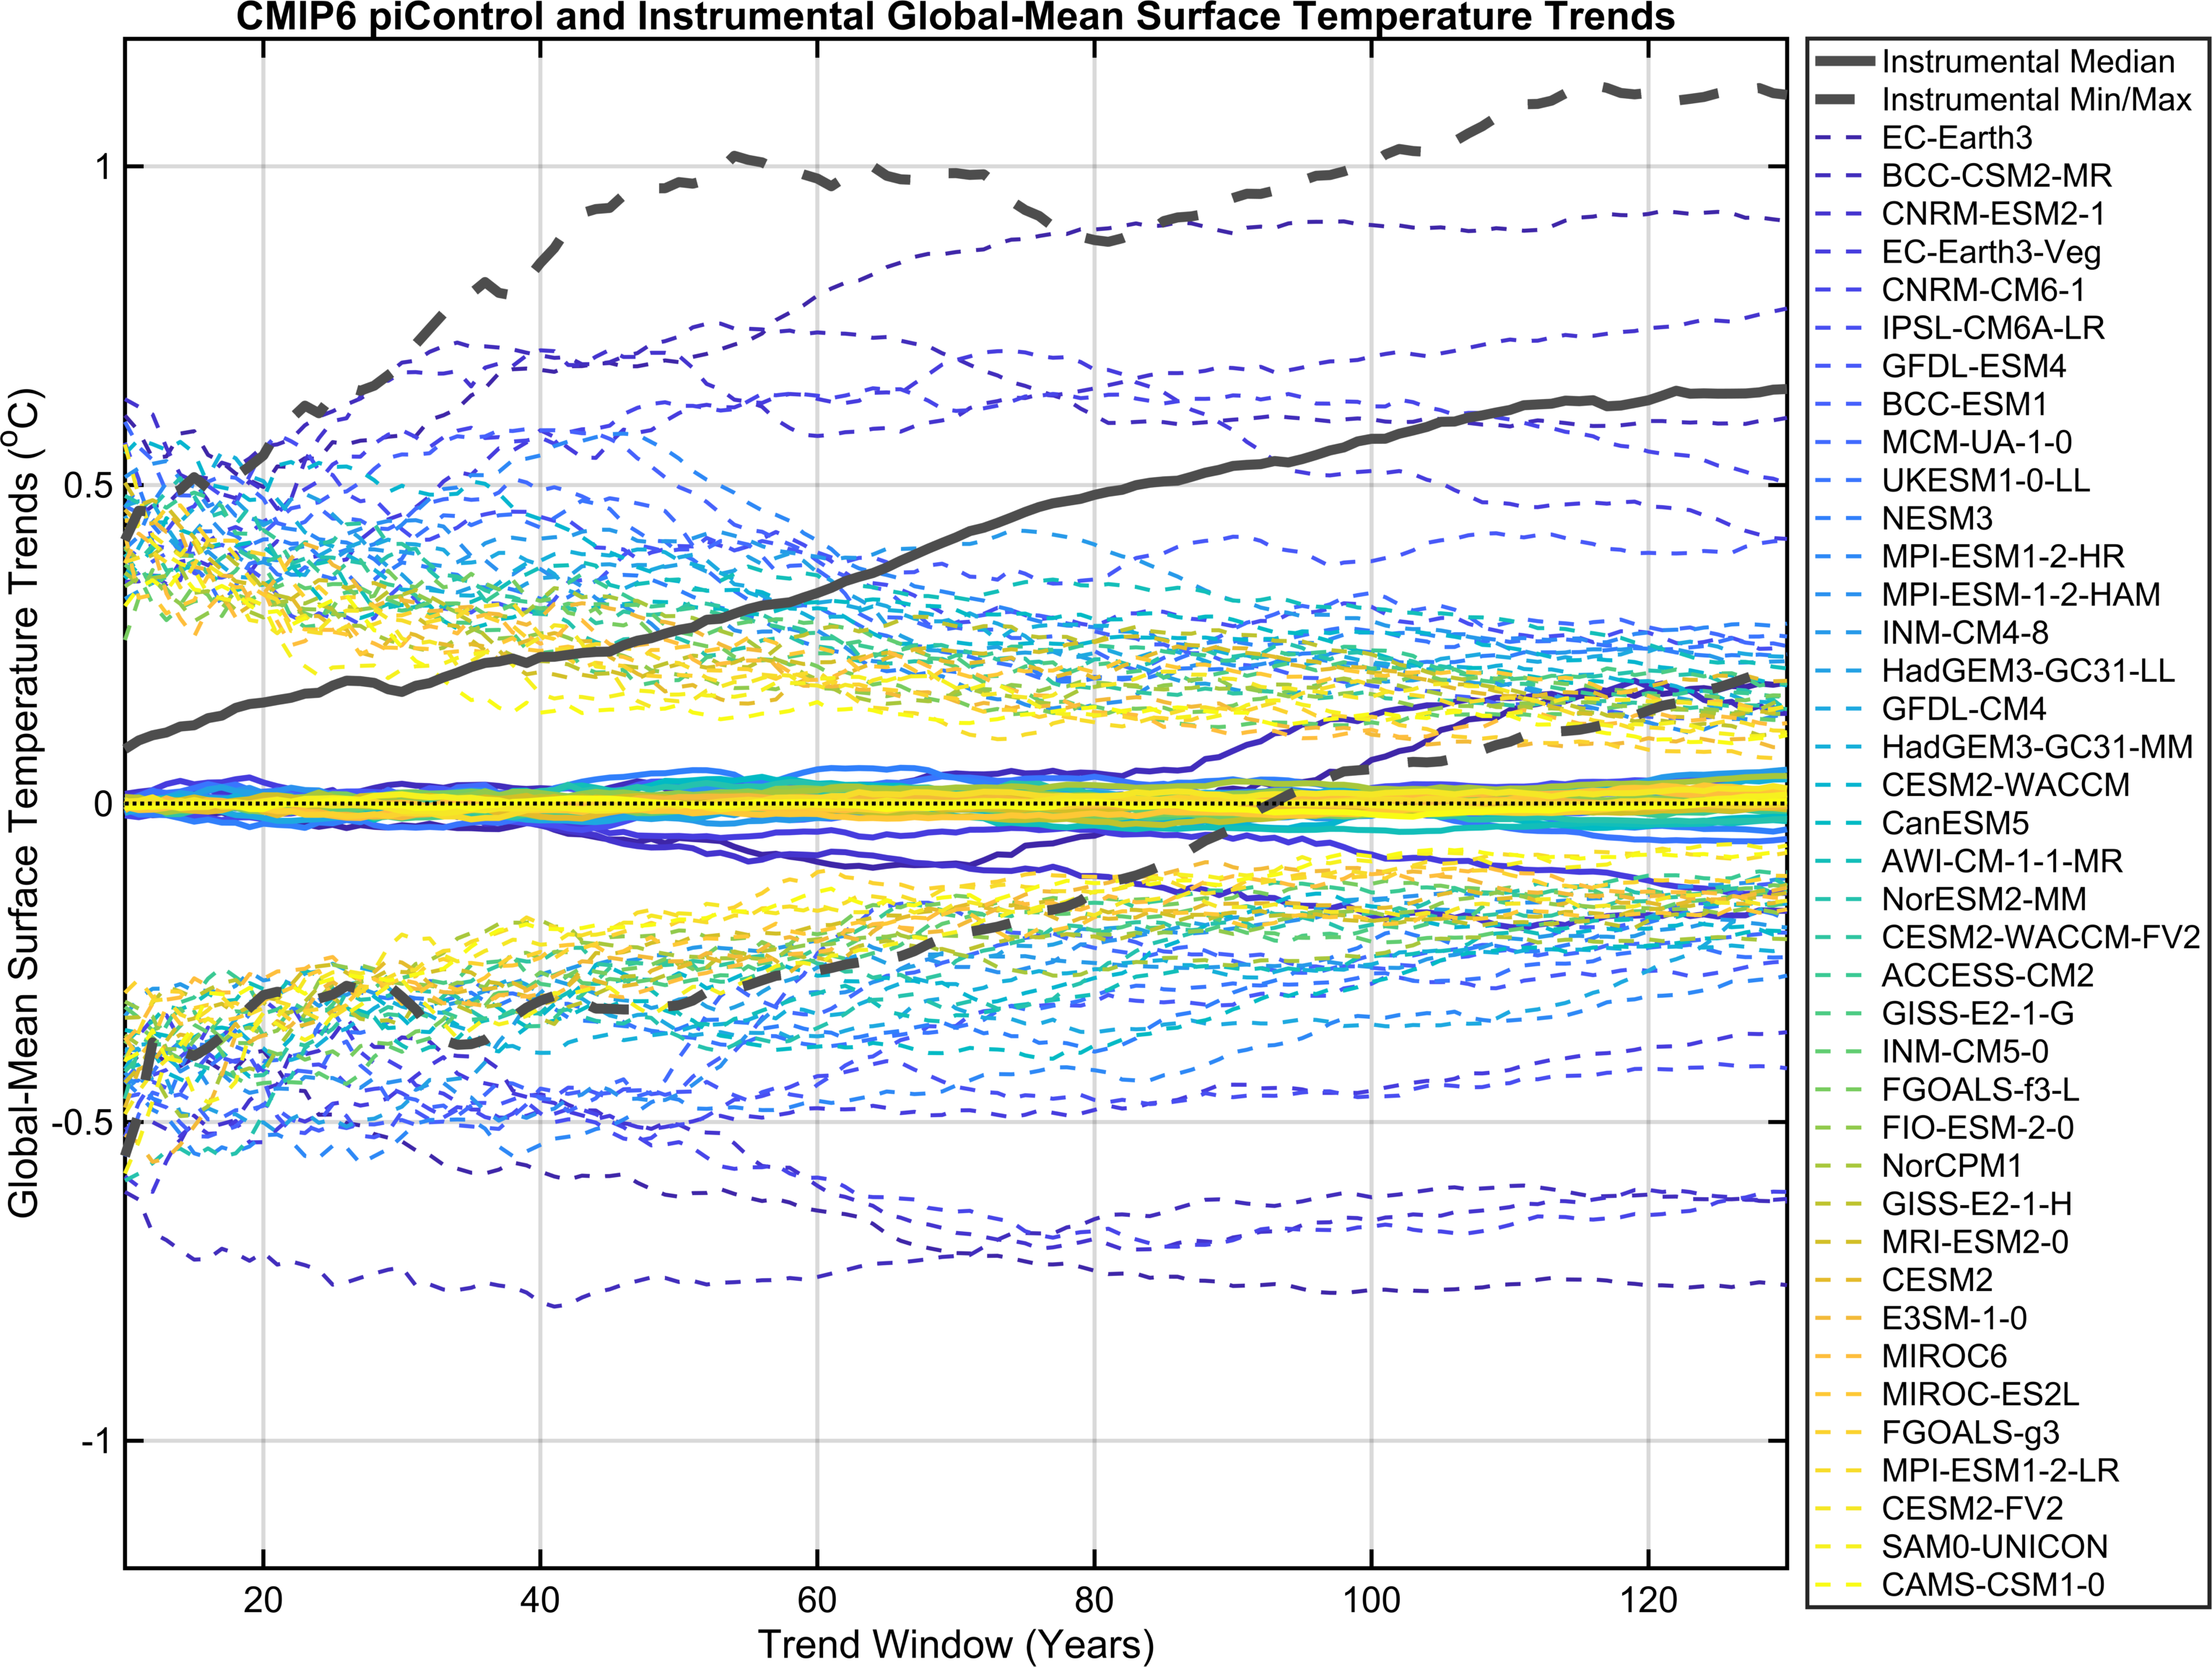
Figure S1. Trends in global-mean surface air temperature (GMST) in 39 Coupled Model Intercomparison Project, Phase 6 (CMIP6) pre-industrial Control (piControl) simulations (colored lines) and instrumental-based data (grey lines). Linear trends are calculated using sliding windows, with widths from 10 to 130 years. Solid lines show median trends and dashed lines show minimum and maximum of the trend for each model or across the five instrumental data sets (GISTEMP, Berkeley Earth, 20th Century Reanalysis v3, HadCRUT4, NOAAGlobalTempv5). Each color shows a different model. Note that the maximum trends in the observations tend to emerge from the piControl maxima at a window width of >30 years.

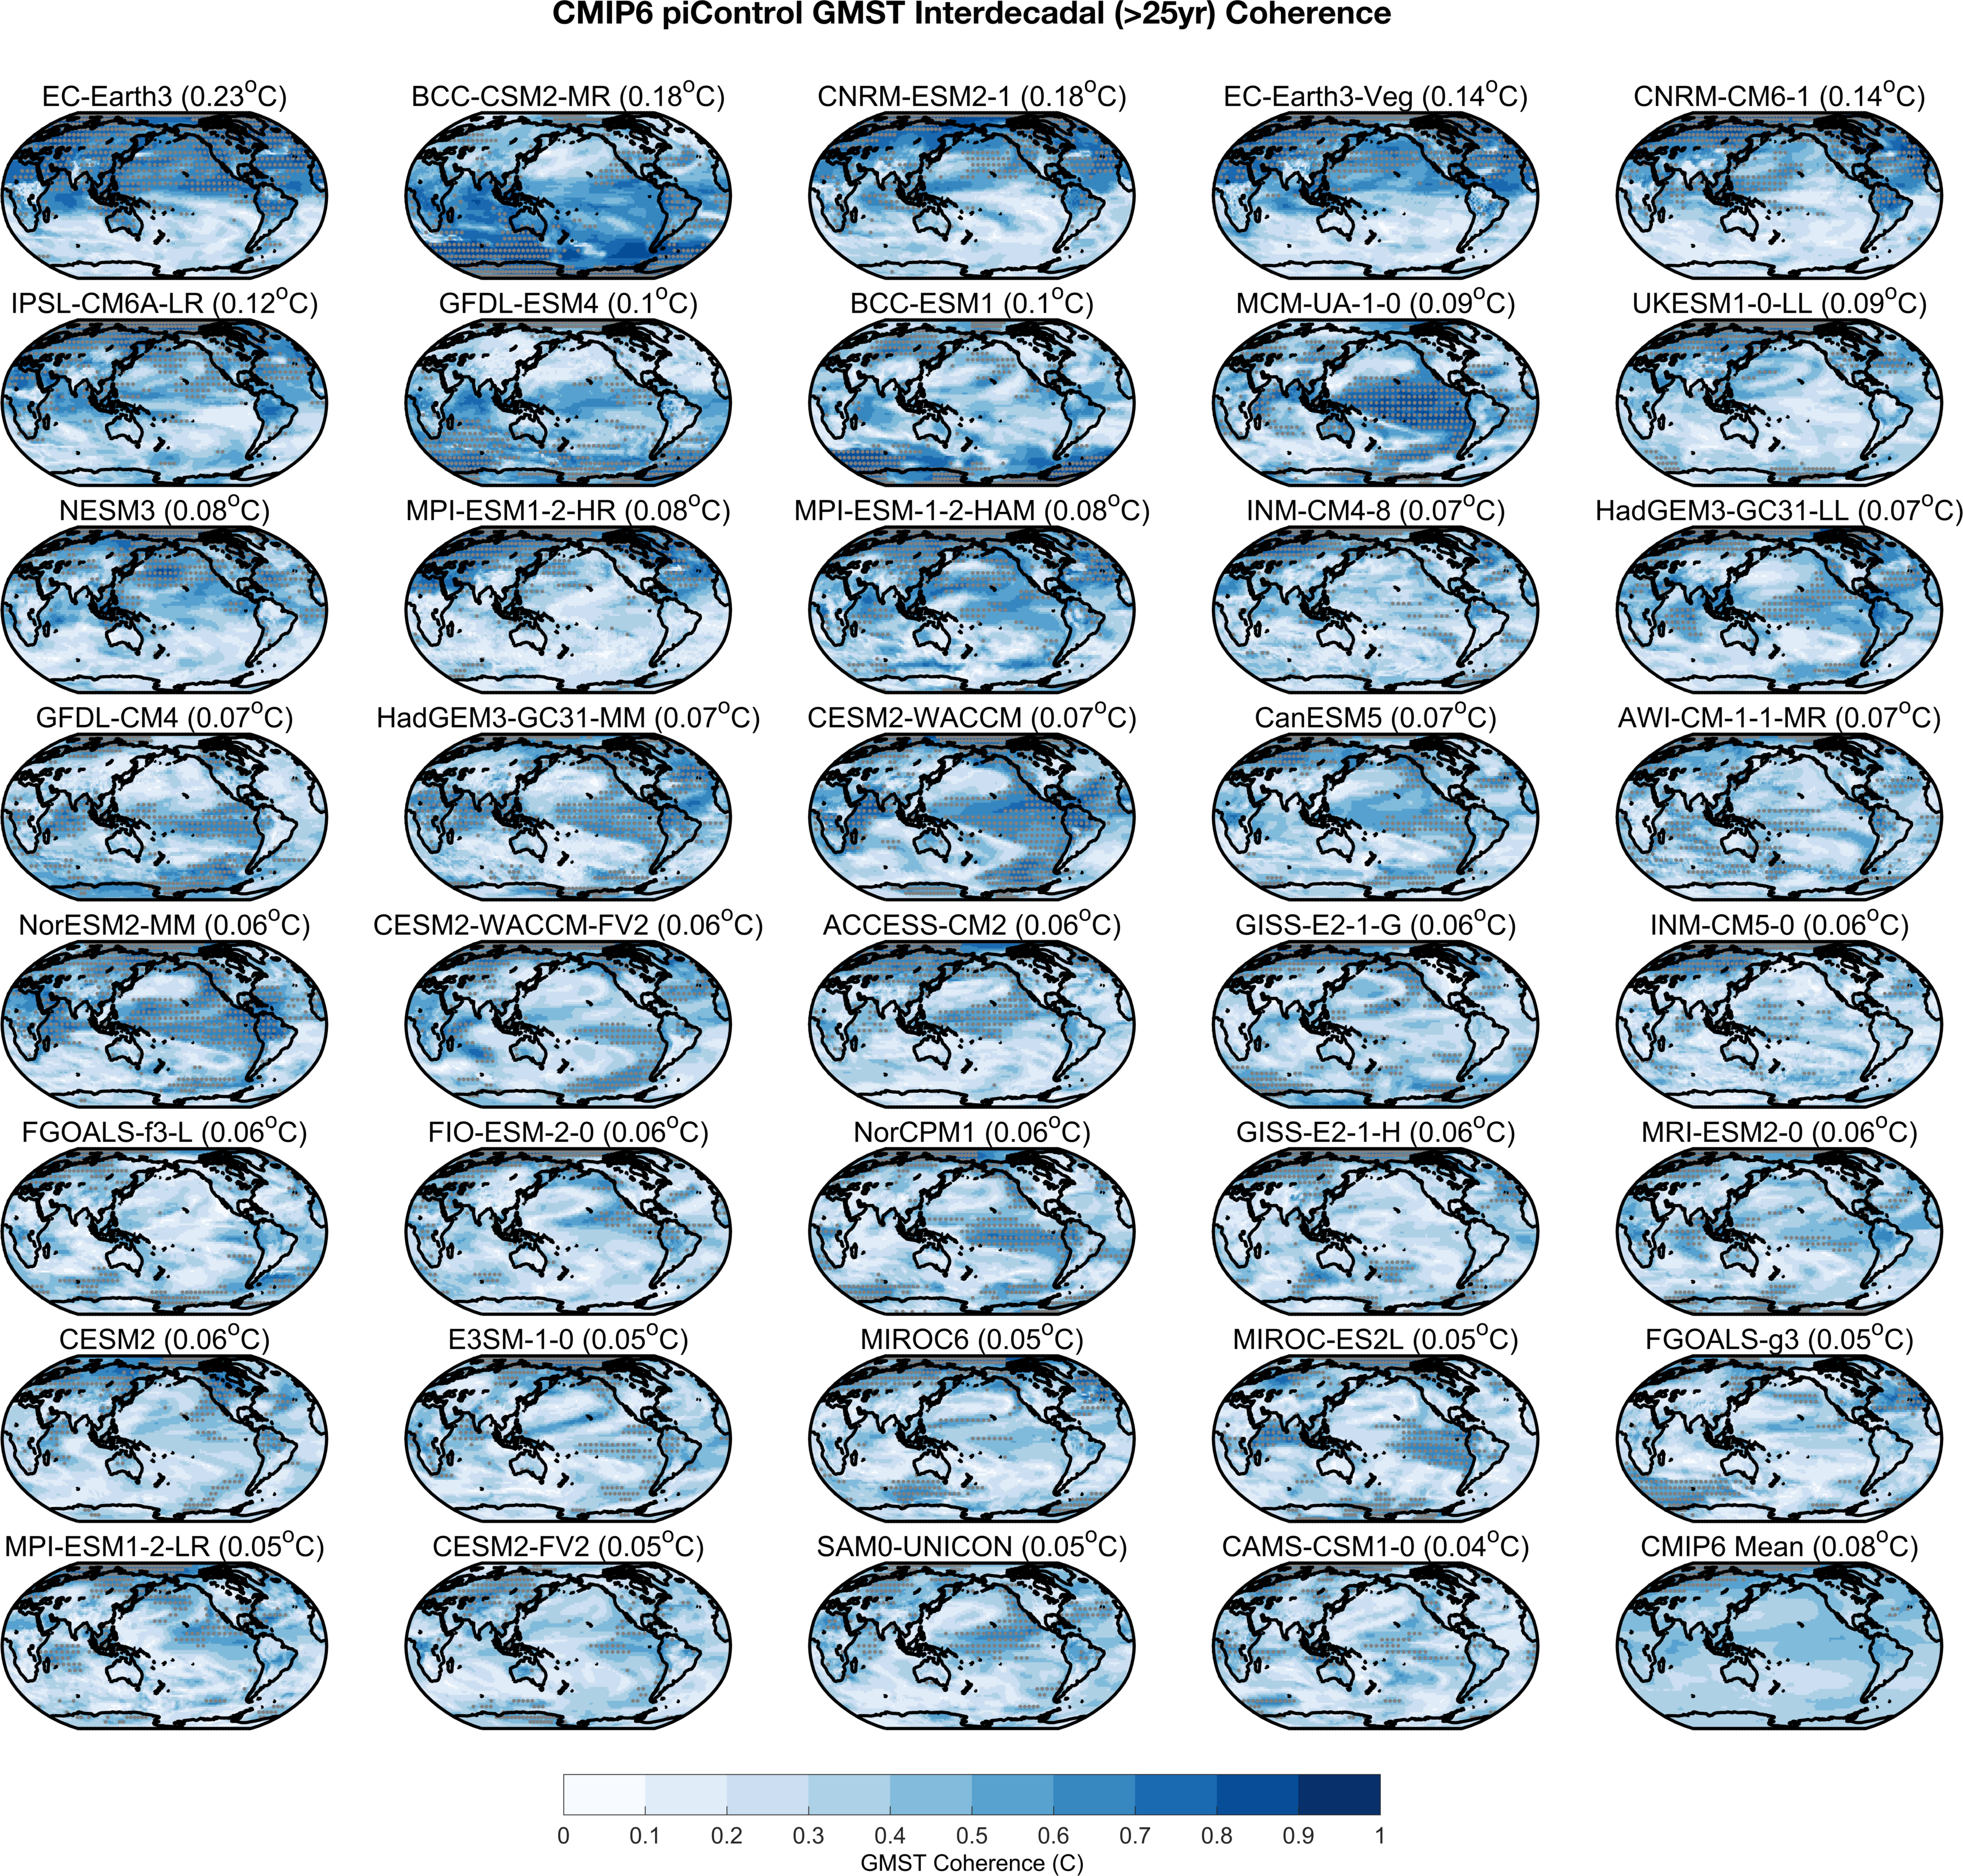

Figure S2. Spectral coherence (C(f)) of local temperature and global-mean surface air temperature (GMST) at interdecadal (f<0.04 yr⁻¹) timescales in the last 400 years of 39 Coupled Model Intercomparison Project, Phase 6 (CMIP6) pre-industrial Control (piControl) simulations. Stippling denotes local geographic regions where the global vs local relationship exceeds the noise threshold and local variability does not lag GMST by more than a year at interdecadal timescales (Methods). Map in lower right corner shows mean coherence across all simulations, with stippling showing grid points where >6/10 models agree a location shows a significant lead relationship with the global-mean at interdecadal timescales. Maps are ordered from greatest to least interdecadal variability (top left to bottom right).

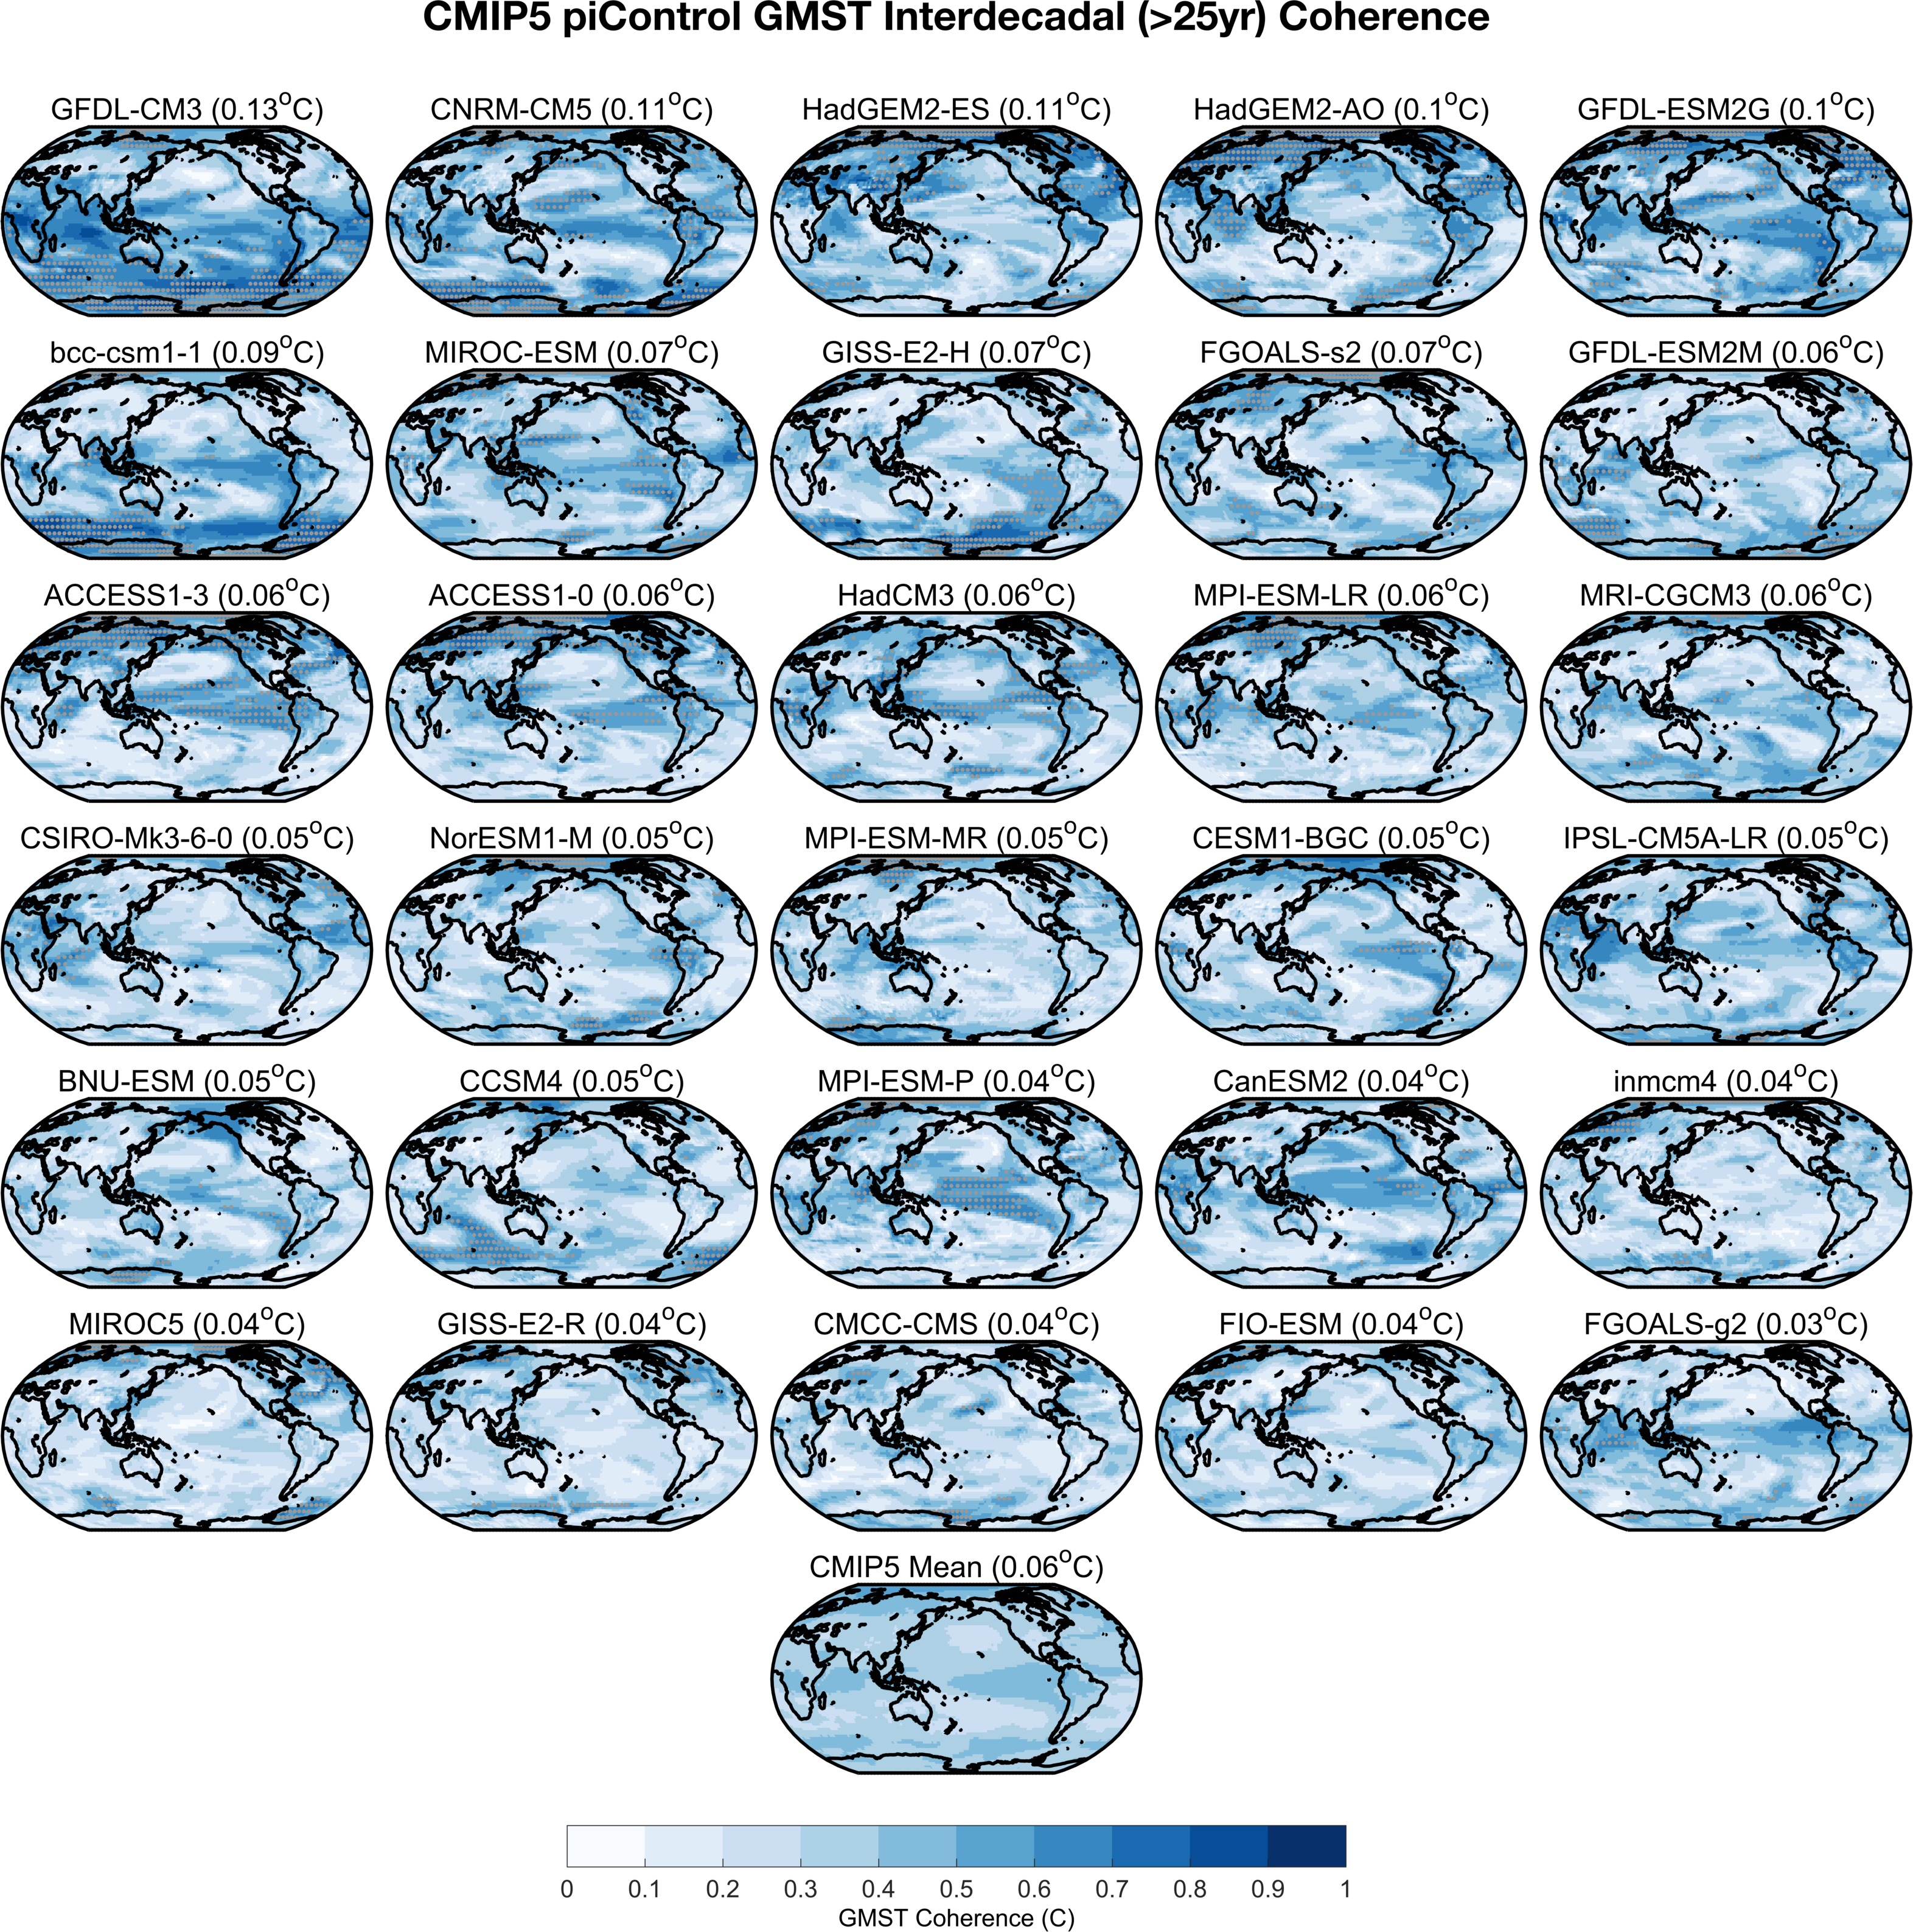

Figure S3. Same as Figure S2, but for the last 400 years of 30 Coupled Model Intercomparison Project, Phase 5 (CMIP5) pre-industrial Control (piControl) simulations.

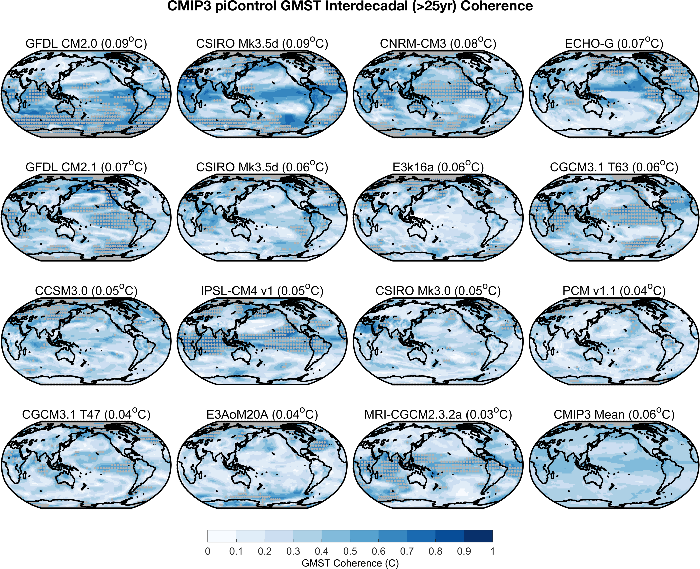

Figure S4. Same as Figure S2, but for the last 330 years of 15 Coupled Model Intercomparison Project, Phase 3 (CMIP3) pre-industrial Control (piControl) simulations.

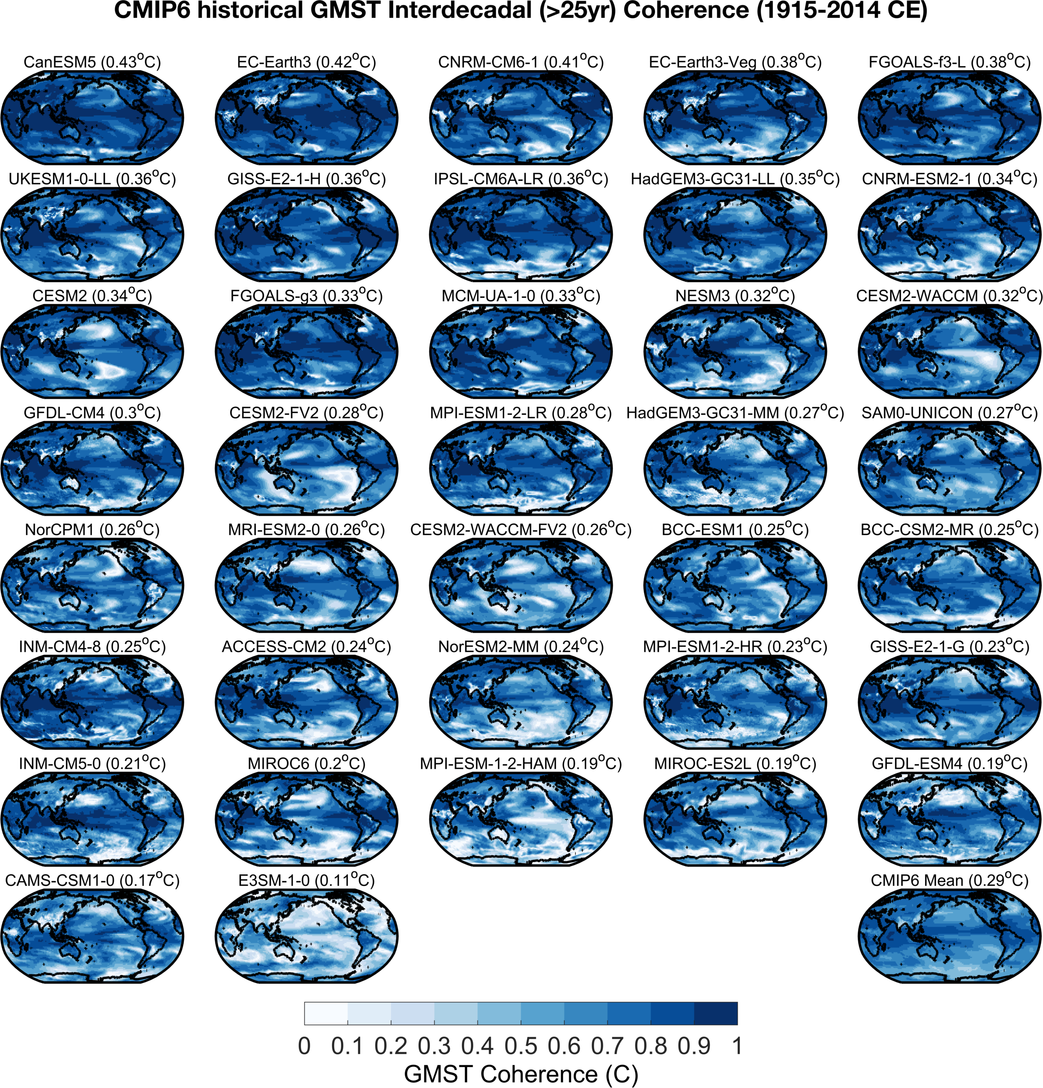Figure S5. Same as Figure S2, but for 1915-2014 CE in 37 Coupled Model Intercomparison Project, Phase 6 (CMIP6) historical simulations. Note that stippling is not shown in this figure.

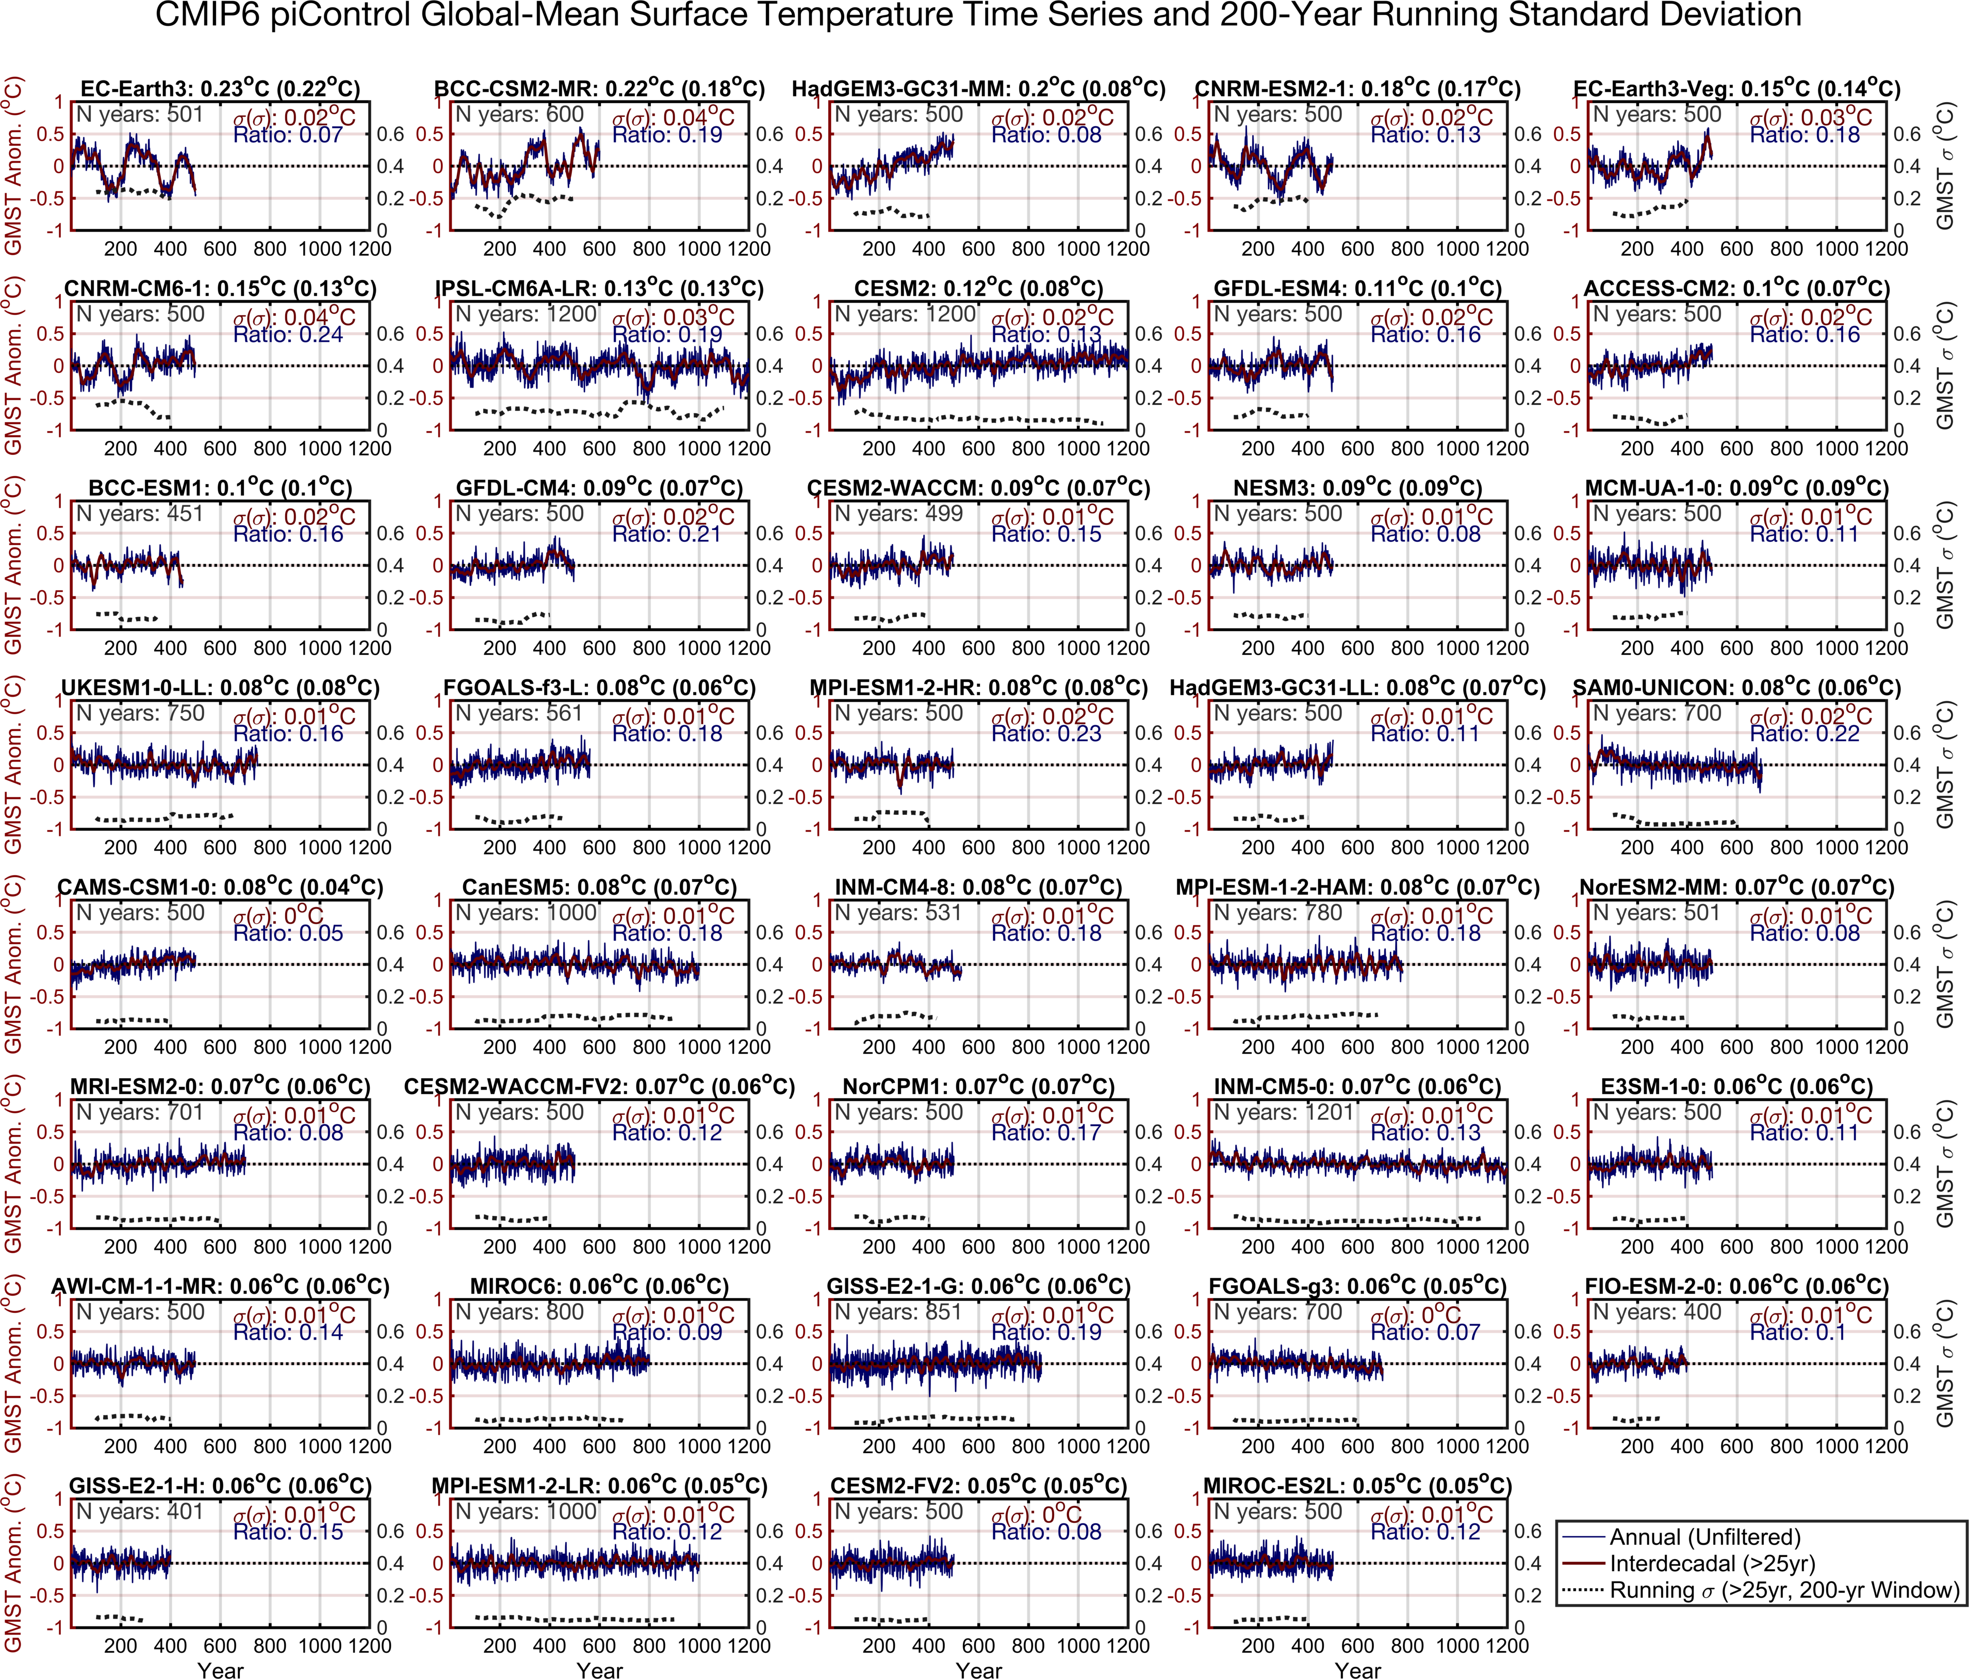

Figure S6. Time series showing the full global-mean surface air temperature (GMST) time series (red and blue lines, left axis) and the running standard deviation of interdecadal variability (dotted, black line, right axis) in 39 CMIP6 piControl simulations. Running standard deviation of GMST interdecadal variability is calculated with a 200-year sliding window. Number to right of each model name shows the standard deviation of the full time GMST time series, and number in parentheses shows the standard deviation after the linear trend has been removed from the GMST time series. Red number in upper right corner of each panel shows the standard deviation of the standard deviation of interdecadal GMST, the blue number shows the ratio of the variability in standard deviation to the standard deviation of the full time series, and the grey number shows the number of years in the piControl simulation used to conduct this analysis.

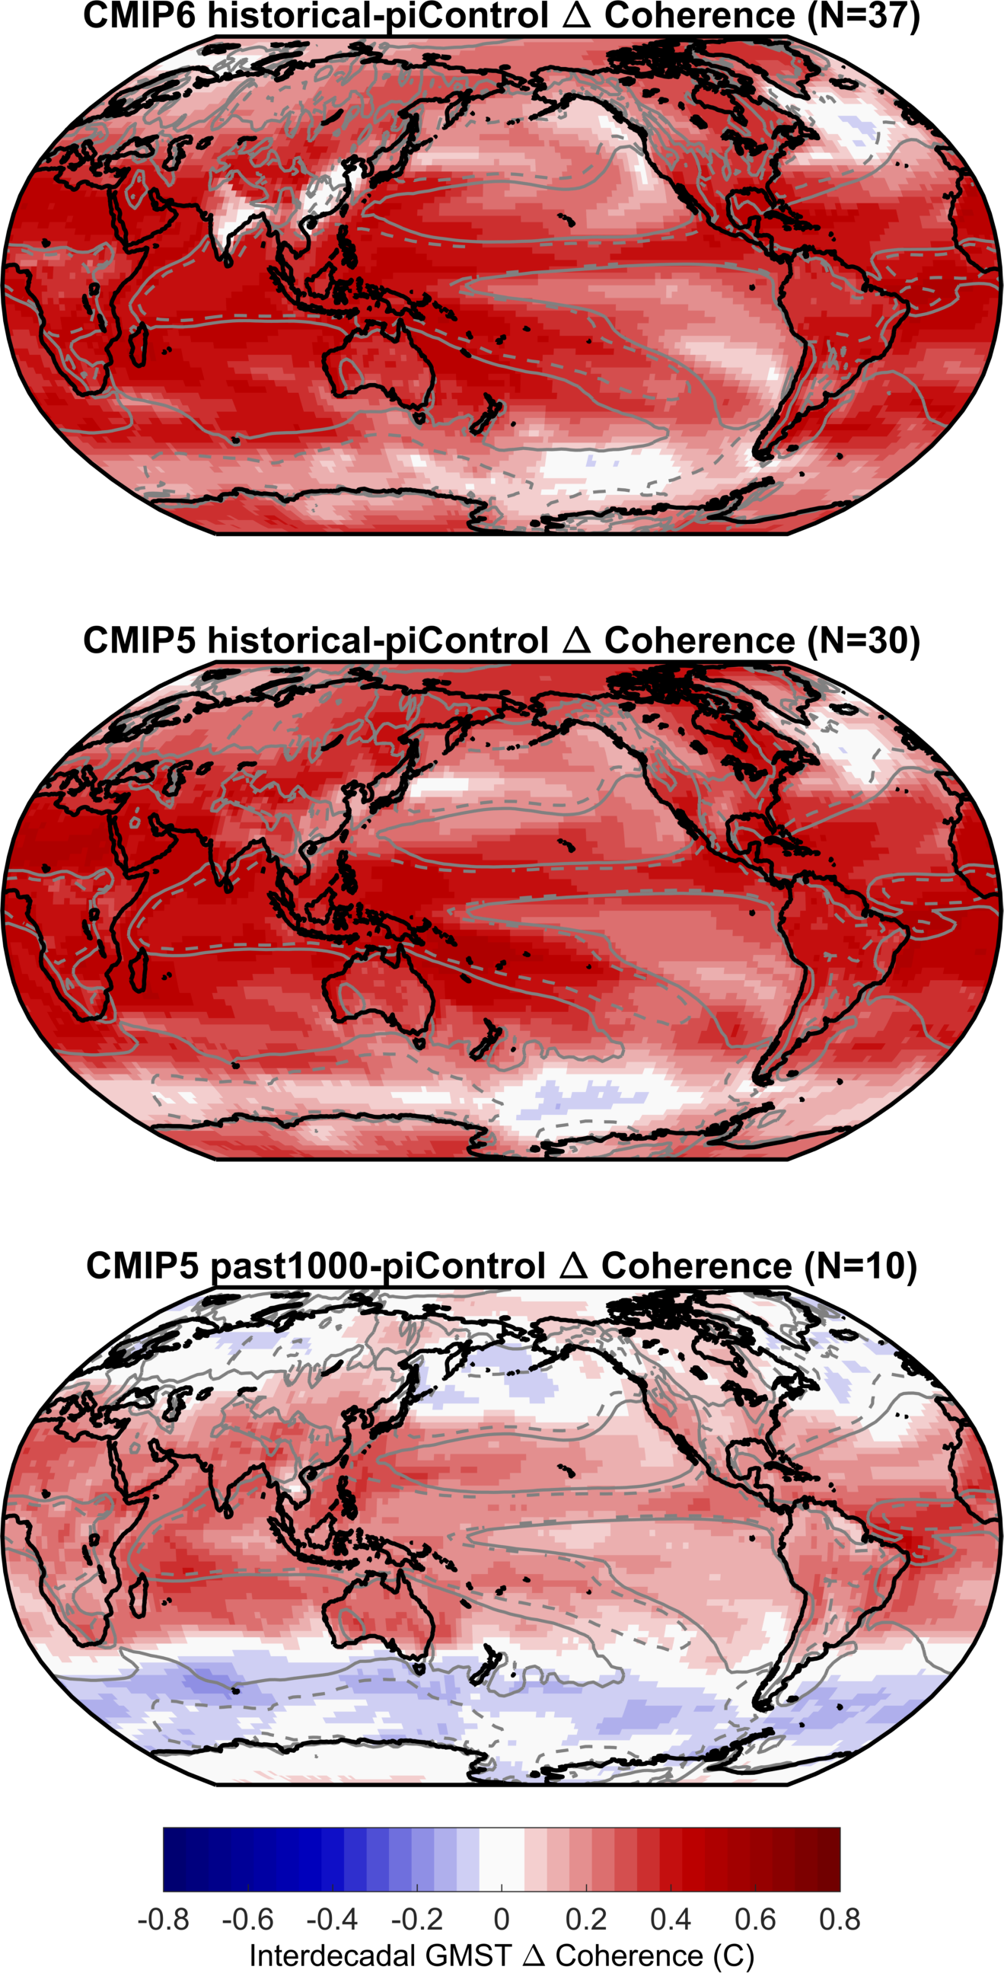

Figure S7. Difference in interdecadal spectral coherence in transiently forced climate model simulations and pre-industrial Control (piControl) model simulations. Top row shows CMIP6 historical-piControl differences, middle row shows CMIP5 historical-piControl differences, and bottom row shows CMIP5 past1000-piControl differences. Red colors indicate more local coherence in the forced simulations, and blue indicates less coherence in the forced simulations. Dashed (solid) grey contour lines in maps outline regions of upward (downward) vertical motion (ω) at 500mb in the last 30 years of the CMIP5 and CMIP6 historical simulations.

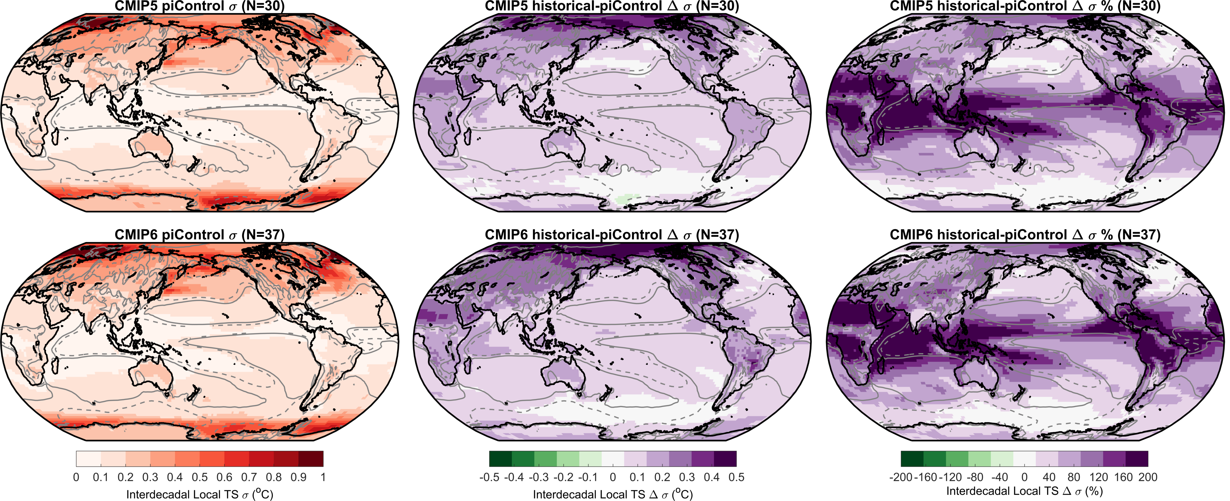
Figure S8. Standard deviation of interdecadal (>25 year) local surface air temperature (TS) variability in CMIP5 (top) and CMIP6 (bottom) piControl simulations (left) and change in interdecadal variability in the historical simulations (center, right). Center panels show change in standard deviation of interdecadal TS variability in historical-piControl simulations, and panels on right show percent change in interdecadal TS variability in historical-piControl simulations relative to the piControl variability. Dashed (solid) grey contours outline regions of upward (downward) vertical motion (ω) at 500mb in the last 30 years of the CMIP5 and CMIP6 historical simulations.

CMIP3 | CMIP5 | CMIP6 | CMIP6 piControl GMST Trend (°C/400 years)
CCSM3.0 | ACCESS1-0 | ACCESS-CM2 | 0.26
CNRM-CM3 | ACCESS1-3 | AWI-CM-1-1-MR | -0.02
CSIRO Mk3.0 | bcc-csm1-1 | BCC-CSM2-MR | 0.32
CSIRO Mk3.5d | BNU-ESM | BCC-ESM1 | 0.05
CGCM3.1 T47 | CCSM4 | CAMS-CSM1-0 | 0.15
CGCM3.1 T63 | CESM1-BGC | CESM2-FV2 | 0.07
ECHO-G | CMCC-CMS | CESM2-WACCM-FV2 | 0.04
E3AoM20A | CNRM-CM5 | CESM2-WACCM | 0.15
E3k16a | CSIRO-Mk3-6-0 | CESM2 | 0.10
IPSL-CM4_v1 | CanESM2 | CNRM-CM6-1 | 0.19
GFDL CM2.0 | FGOALS-g2 | CNRM-ESM2-1 | -0.08
GFDL CM2.1 | FGOALS-s2 | CanESM5 | -0.10
MRI-CGCM2.3.2a | FIO-ESM | E3SM-1-0 | -0.03
PCM v1.1 | GFDL-CM3 | EC-Earth3-Veg | 0.28
 | GFDL-ESM2G | EC-Earth3 | 0.02
 | GFDL-ESM2M | FGOALS-f3-L | 0.13
 | GISS-E2-H | FGOALS-g3 | -0.09
 | GISS-E2-R | FIO-ESM-2-0 | 0.04
 | HadCM3 | GFDL-CM4 | 0.17
 | HadGEM2-AO | GFDL-ESM4 | 0.17
 | HadGEM2-ES | GISS-E2-1-G | 0.03
 | inmcm4 | GISS-E2-1-H | 0.01
 | IPSL-CM5A-LR | HadGEM3-GC31-LL | 0.08
 | MIROC-ESM | HadGEM3-GC31-MM | 0.52
 | MIROC5 | INM-CM4-8 | -0.14
 | MPI-ESM-LR | INM-CM5-0 | -0.01
 | MPI-ESM-MR | IPSL-CM6A-LR | -0.05
 | MPI-ESM-P | MCM-UA-1-0 | -0.08
 | MRI-CGCM3 | MIROC-ES2L | -0.01
 | NorESM1-M | MIROC6 | 0.13
 |  | MPI-ESM-1-2-HAM | -0.01
 |  | MPI-ESM1-2-HR | 0.00
 |  | MPI-ESM1-2-LR | 0.00
 |  | MRI-ESM2-0 | 0.06
 |  | NESM3 | 0.05
 |  | NorCPM1 | -0.06
 |  | NorESM2-MM | 0.03
 |  | SAM0-UNICON | -0.08
 |  | UKESM1-0-LL | 0.03

Table S1. List of pre-industrial Control (piControl) simulations from CMIP3, CMIP5, and CMIP6 models used in figures and text. CMIP3, CMIP5, and CMIP6 historical simulations are listed in bold font. Column on right shows the linear trend in global-mean surface air temperature in the last 400 years of each CMIP6 piControl simulation if no linear trend is removed from local TS data.

